06/01/19
THM 348 Service Operations Management
Final Exam Answer Sheet
- In his effort to improve the quality of its hotel, Jamel Chafra, the general manager of a prestigious 5-star hotel located in Mersin, analyzed various “Complaint Cards” filled by customers for the last 12 weeks. The following problematic areas along with their frequencies were observed:
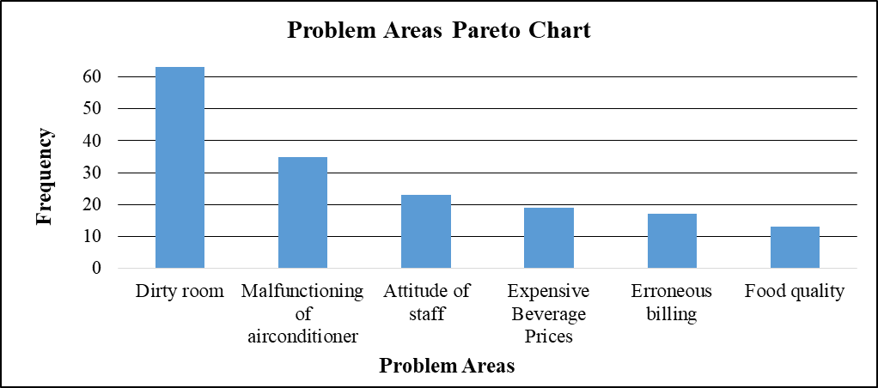
- Prepare a Pareto Chart for the above data. (2 Points)

- As “Dirty room” problem had the highest frequency amongst the other problems, Jamel Chafra decided to tackle it first. He ma de several brainstorming meeting with Rooms Division manager as well as Housekeeping manager at the end of which they decided there is a need to re-train the existing housekeeping staff. For the upcoming month, the hotel conducted related training sessions. After a while, the general manager wanted to see if there are any quality improvements in the process. For that, he decided to use run chart. He prepared the following table depicting weekly customer complaints (before / after re-training). The following table reveals the following results:
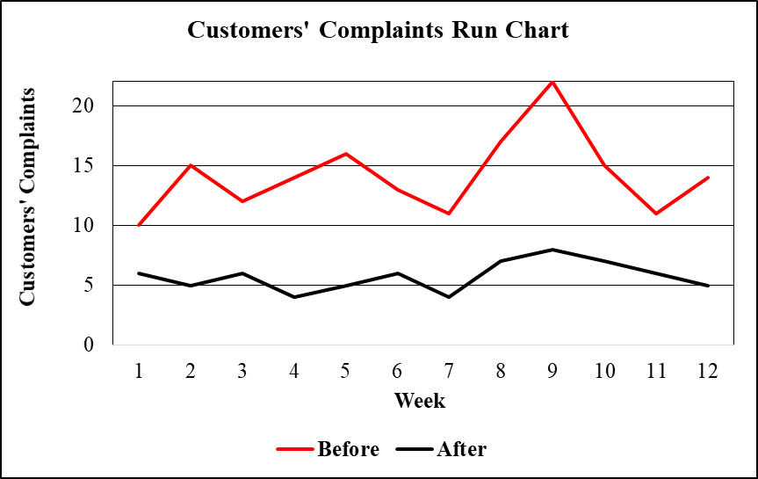
Prepare a run chart to compare customer complaints before and after re-training housekeeping staff. (2 Points)

- Analyze the finding in part b). Is there any improvement as far as customers’ complaints are concerned after re-training housekeeping staff? If there is an improvement, what is the next problem that Jamel Chafra shall try and solve? Explain the reason behind your answer. (1 Point)
As seen from the run chart prepared in part b), there is a clear improvement as far as customers’ complaints are concerned after re-training housekeeping staff. The next problem that Jamel Chafra shall try and solve is “Malfunctioning of air conditioner” because the frequency associated with this very problematic area is the highest after “Dirty room” problem.
- What is “Bidirectional Optimization”? Provide one example clarifying this. (2 Points)
Bidirectional Optimization refers to a situation when the service provider and the customer agree on the time a service should be delivered, taking into account the needs of both parties. An example could be offering the customer a “time window” (say Friday from 08:40 – 12:30) in which service personnel will come to repair your malfunctioning refrigerator.
- What are some of the management concerns when dealing with equipment support service outsourcing? (2 Points)
Some management concerns when dealing with equipment support service outsourcing might be as follows:
- Vendor location
- Vendor expertise / reputation
- Emergency service provision
- Work performed quality
- Communication problems
- Degree of dependability
- Repair
- Maintenance
- Product testing
- Briefly explain any 3 benefits of franchising to the franchisee? (3 Points)
Some benefits of franchising to the franchisee might be as follows:
- Management training
- Brand name
- National advertising
- Acquisition of a proven business
- Economies of scale
- Briefly explain how, by going global, you manage to neutralize your company’s exposure to fluctuating currency exchange rates? (2 Points)
By going global, you can neutralize your company’s exposure to fluctuating currency exchange rates by matching costs to revenues and becoming strong in all regions of the Triad (America, Asia and Europe) so that if one region is negative, it may be offset by others that are positive.
- During the past season, Toure Resort Hotel did not achieve very high occupancy rates despite a reservation system that was designed to keep the hotel fully booked. Apparently, prospective guests were making reservations that, for one reason or another, they failed to honor. A review of Front-desk records during the current peak period, when the Resort Hotel was fully booked, revealed the record of no-shows as shown in the below table:
No-shows | Probability | Reservations Overbooked | Cumulative Probability
0 | 0.05 | 0 | 0.00
1 | 0.06 | 1 | 0.05
2 | 0.07 | 2 | 0.11
3 | 0.08 | 3 | 0.18
4 | 0.13 | 4 | 0.26
5 | 0.21 | 5 | 0.39
6 | 0.15 | 6 | 0.60
7 | 0.10 | 7 | 0.75
8 | 0.08 | 8 | 0.85
9 | 0.05 | 9 | 0.93
10 | 0.02 | 10 | 0.98
Suppose that a vacant room (because of No Show) results in an opportunity loss of $ 85.
- Calculate the Expected Number of No Show Rooms. (2 Points)
- Expected number of no show rooms = (0.05 * 0) + (0.06 * 1) + (0.07 * 2) + (0.08 * 3) + (0.13 * 4) + (0.21 * 5) + (0.15 * 6) + (0.10 * 7) + (0.08 * 8) + (0.05 * 9) + (0.02 * 10) = 0 + 0.06 + 0.14 + 0.24 + 0.52 + 1.05 + 0.90 + 0.70 + + 0.64 + 0.45 + 0.20 = 4.90 rooms.
- Calculate the Expected Opportunity Loss. (1 Point)
- Expected Opportunity Loss = 4.90 * 85 = $ 416.50.

In order to avoid some of this loss, Toure Resort Hotel management is considering an overbooking policy. Yet, if a guest holding a reservation is turned away (due to overbooking), other costs would be incurred. Toure Resort Hotel has made arrangements with a nearby Resort Hotel (Yaya Resort Hotel) to pay for the rooms of guests whom it cannot accommodate. Further, a penalty is associated with the loss of customer goodwill and the impact this has on future business. Management estimates this total loss to be approximately $ 140 per turned out guest.

- Fill the below Overbooking Loss Table (4 Points)

 |  | Reservations Overbooked
No-shows | Prob. | 0 | 1 | 2 | 3 | 4 | 5 | 6 | 7 | 8 | 9 | 10
0 | 0.05 | $0 | $140 | $280 | $420 | $560 | $700 | $840 | $980 | $1,120 | $1,260 | $1,400
1 | 0.06 | $85 | $0 | $140 | $280 | $420 | $560 | $700 | $840 | $980 | $1,120 | $1,260
2 | 0.07 | $170 | $85 | $0 | $140 | $280 | $420 | $560 | $700 | $840 | $980 | $1,120
3 | 0.08 | $255 | $170 | $85 | $0 | $140 | $280 | $420 | $560 | $700 | $840 | $980
4 | 0.13 | $340 | $255 | $170 | $85 | $0 | $140 | $280 | $420 | $560 | $700 | $840
5 | 0.21 | $425 | $340 | $255 | $170 | $85 | $0 | $140 | $280 | $420 | $560 | $700
6 | 0.15 | $510 | $425 | $340 | $255 | $170 | $85 | $0 | $140 | $280 | $420 | $560
7 | 0.10 | $595 | $510 | $425 | $340 | $255 | $170 | $85 | $0 | $140 | $280 | $420
8 | 0.08 | $680 | $595 | $510 | $425 | $340 | $255 | $170 | $85 | $0 | $140 | $280
9 | 0.05 | $765 | $680 | $595 | $510 | $425 | $340 | $255 | $170 | $85 | $0 | $140
10 | 0.02 | $850 | $765 | $680 | $595 | $510 | $425 | $340 | $255 | $170 | $85 | $0
Expected | ------- | 416.50 | 342.75 | 282.50 | 238.00 | 211.50 | 214.25 | 264.25 | 348.00 | 454.25 | 578.50 | 714.00
Loss ($)
- How many rooms shall be overbooked? Why? (2 Points)
According to the above overbooking loss table, 4 rooms shall be overbooked, since, this very scenario yields the least expected loss.
N.B: Your answers to parts a), b) c) & d) shall be rounded to the nearest cent.
- Briefly explain how promoting off-peak demand levels capacity. Provide 1 example clarifying this point. (2 Points)
Promoting off-peak demand will increase the utilization of the resources especially for products / services suffering seasonality problems. This will lead to more utilization in low demanded periods and serve as to adjust demand to supply and hence level capacity. An example to illustrate this is a mountain ski resort that becomes a staging area for backpacking during the summer.
Good Luck

